Table of Contents

1.Construct design steps 2

1.1 Decide on the context of the interaction: system, subsystem 2

2.0 Identify the structural elements necessary to carry out the functionality of the use case or operation 5

3.0 Consider the alternative scenarios that may be required. 6

4.0 Starting with the message that starts the interaction, lay out the messages down the page from top to bottom. 7

5.0 Identify the structural elements necessary to carry out the functionality of the use case or operation 14

6.0 Attach annotations to the sequence diagram if required, for example pre- and post-conditions 14

7.0 Identify business actors and business use cases 16

8.0 identifying key scenarios of business use cases, using primary and alternative paths 21

9.0 Attach annotations to the sequence diagram 22

10.0 Reference 23

# 1.Construct design steps

## 1.1 Decide on the context of the interaction: system, subsystem

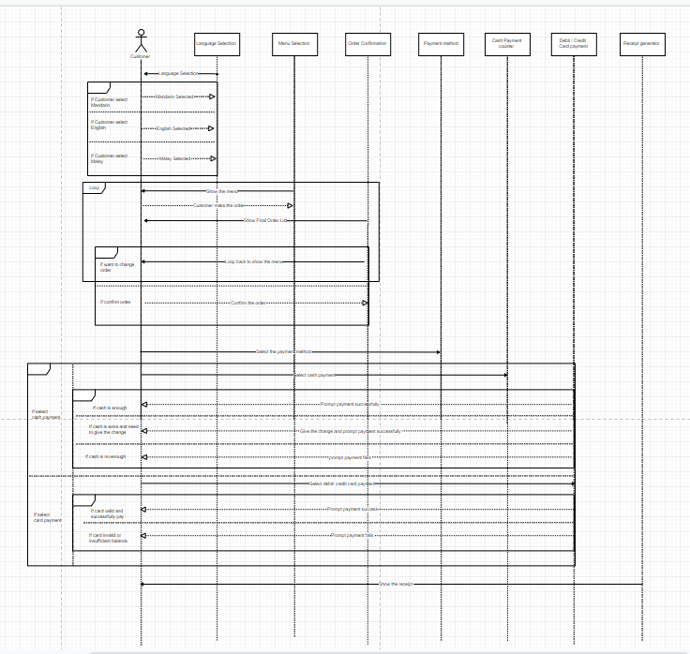Screenshot 1.0

Screenshot 1.0 shows the **system** which is the order system in sequence diagram.

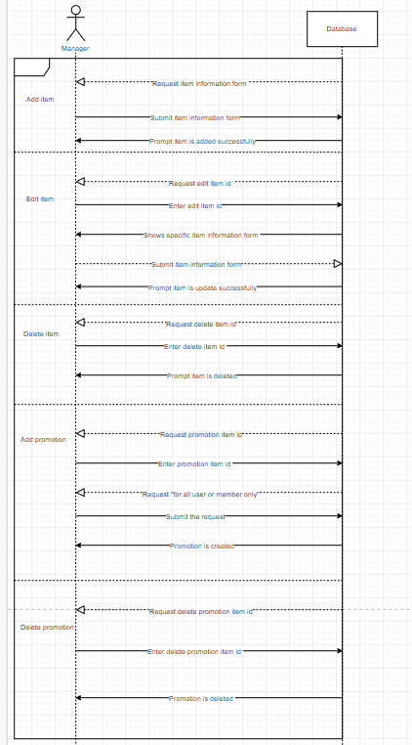

Screenshot 2.0

Screenshot 2.0 shows the **sub-system** which is the manager management system in sequence diagram.

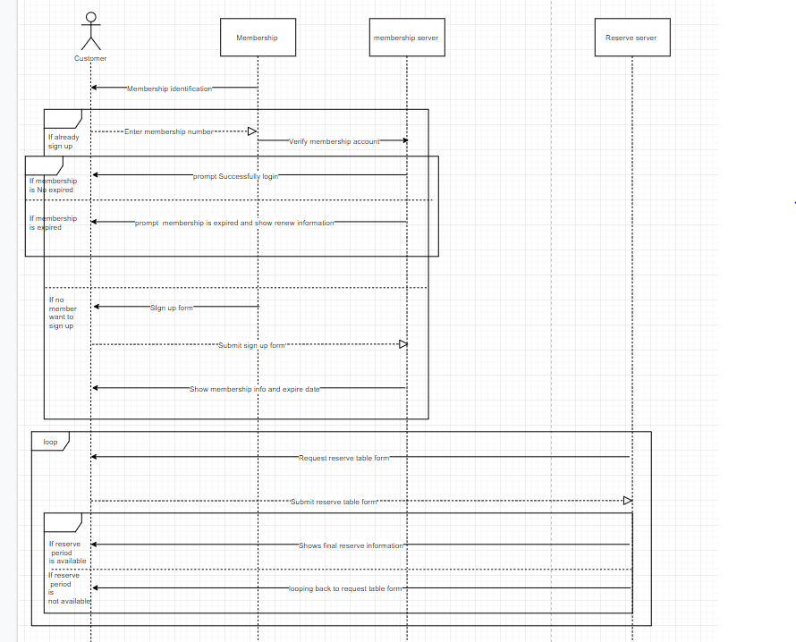

Screenshot 3.0

Screenshot 3.0 shows **another sub-system** which is the membership and reservation management system in sequence diagram.

## 

# 2.0 Identify the structural elements necessary to carry out the functionality of the use case or operation

Object that involved into sequence diagram:

1. Customer
2. Manager
3. Language Selection
4. Menu Selection
5. Order Confirmation
6. Payment method
7. Cash Payment counter
8. Debit / Credit Card payment
9. Receipt generator
10. Membership
11. Membership server
12. Reservation server
13. Item Database

# 

# 3.0 Consider the alternative scenarios that may be required.

**1 scenarios**

First - the cash is enough

Second - the cash is not enough it will prompt payments fails and loop back to select payment method.

**2 scenarios**

First- The final order is confirm

Second - final order is not confirm and looping back to show the menu and customer can edit the order again.

**3 scenarios**

First - The card is valid and successfully paid.

Second - The card is not valid or not enough balance, system will automate looping back to select payment method.

**4 scenarios**

First - membership is valid

Second - membership is expired, will require customer to renew their membership.3

**5 scenarios**

First - reserve period is available and booked

Second - reserve period is not available, shows reservation form to customer to select the period of time again

# 4.0 Starting with the message that starts the interaction, lay out the messages down the page from top to bottom. show the properties of the messages necessary to explain the semantics of the interaction

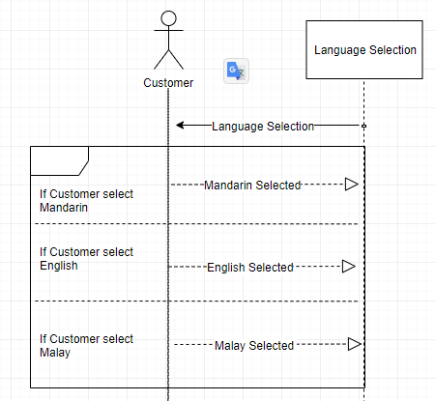

Screenshot 4.0

Screenshot 4.0 shows Customer is interactive to language selection object.Firstly, get the user input to know what is the language chosen by the customer.

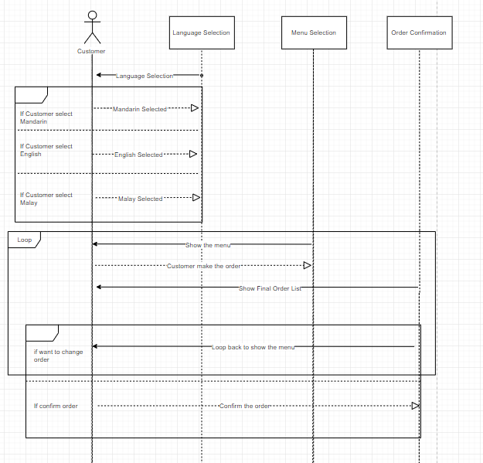

Screenshot 4.1

Screenshot 4.1 shows Customer is interactive to Menu selection object and order confirmation object.Firstly, show the menu to customer and let customers to make an order. If customer wants to change the final order it will loop back to show menu and let customer to order again.

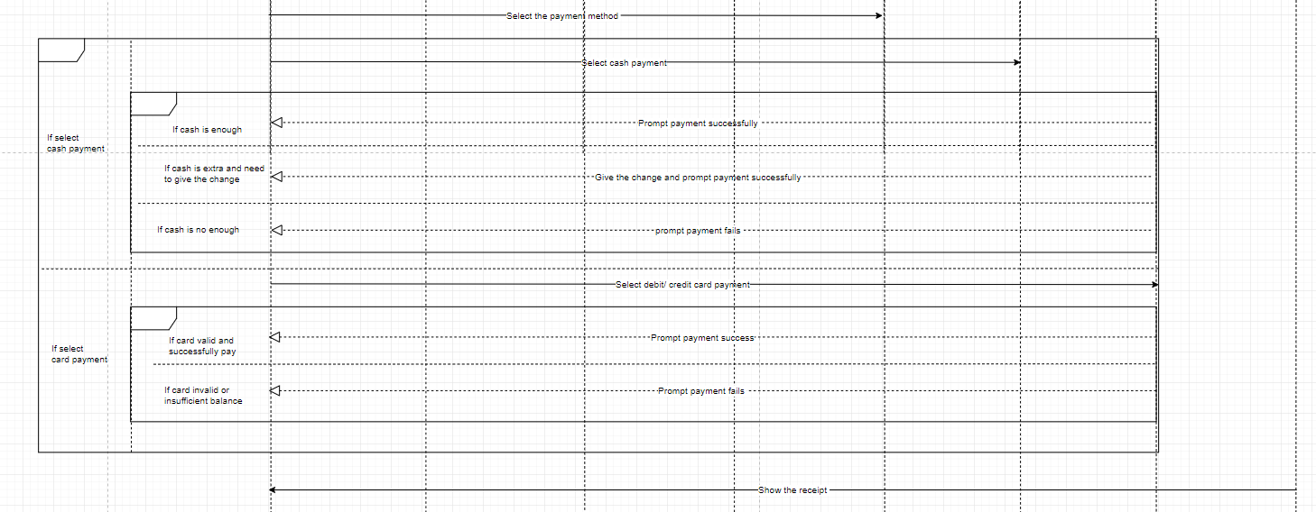

Screenshot 4.2

Screenshot 4.2 shows the payment process after the final confirm order.this system accept cash payment and card payment.after the payment process,receipt will show to customers.

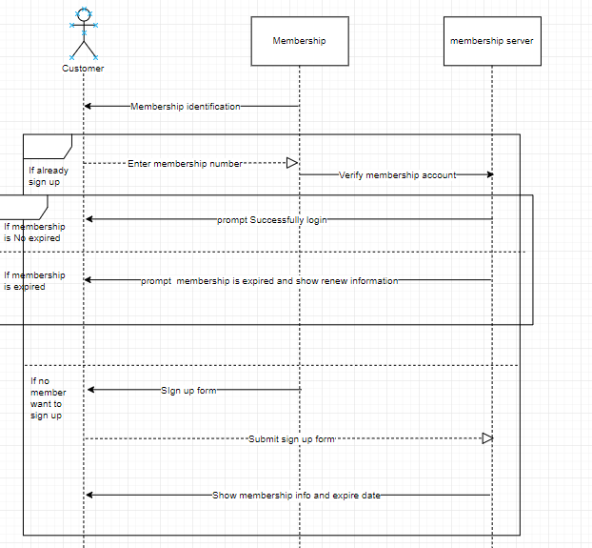

Screenshot 4.3

Screenshot 4.3 shows membership identification process.if customer already sign up for a membership it required to enter membership number. This number will be sent to membership server and check whether the membership is expired or not. If membership is expired then customer need to renew.if membership is active then system will prompt login successfully.For the new customer that haven't signed up before, the system will give a sign up form to the customer.After the customer sign up, the system will show the membership info and expire date.

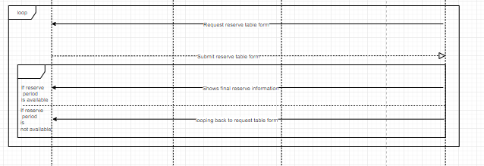

Screenshot 4.4

Screenshot 4.4 shows the reservation process after membership identification process.Firstly customer required to fill up the reserve table form and the form will submit to reserve server to check whether the table is it available for the specific time.if the reserve period is no available,customer need to fill up with another period of reserve time.But if the reserve period is available system will show the final reserve information.

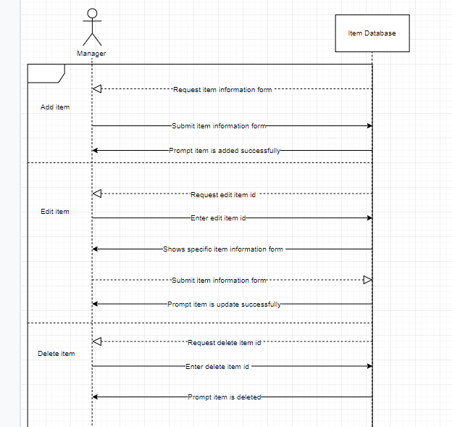

Screenshot 4.5

Screenshot 4.5 shows the Manager site, system allows the manager to edit, delete, add item.

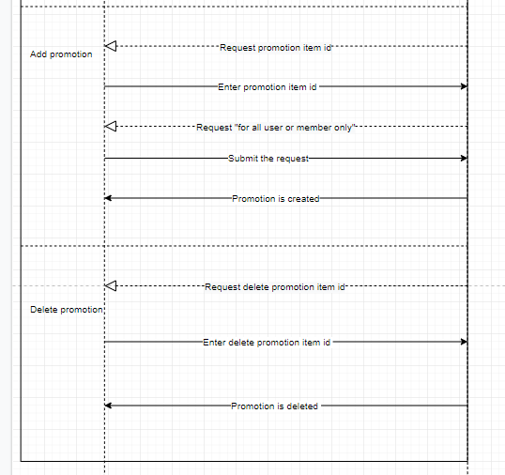

Screenshot 4.6

Screenshot 4.6 shows the Manager site, system allows the manager to Add and delete promotion based on the item id. In add promotion, system will request for the item id. System will also request it is for all user or member only.In delete promotion, system will request the promotion item id that manager want to delete and complete the task.

# 

# 5.0 Identify the structural elements (classes or objects) necessary to carry out the functionality of the use case or operation

5.1 Looping

Using looping function to complete the task when customer need to change menu or some action fails and need to go back to the previous step.

5.2 If else….

Using if else to solve when an action fails in sequence diagram then it will proceed to another way

# 

# 6.0 Attach annotations to the sequence diagram if required, for example pre- and post-conditions



Screenshot 5.0

Screenshot 5.0 shows the actor that name customer in the sequence diagram use to interact with other objects.

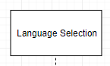

Screenshot 5.1

Screenshot 5.1 shows an object, use for interaction in sequence diagram. Is it also represent a sender and receivers.



Screenshot 5.2

Screenshot 5.2 shows a send action arrow, it use to send messages by each object.



Screenshot 5.3

Screenshot 5.3 shows a reply action arrow, it use to receive the response messages by each object.



Screenshot 5.3

Screenshot 5.3 shows an execution time of the process

# 

# 7.0 Identify business actors and business use cases

There are the business actors which are manager and customers.

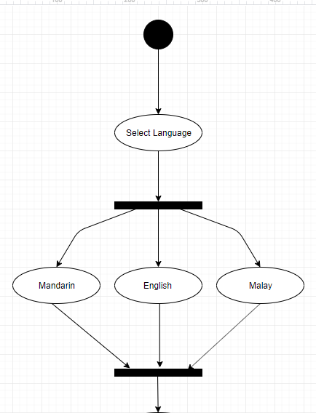

Screenshot 6.0

Screenshot 6.0 shows selecting language use cases for customers.

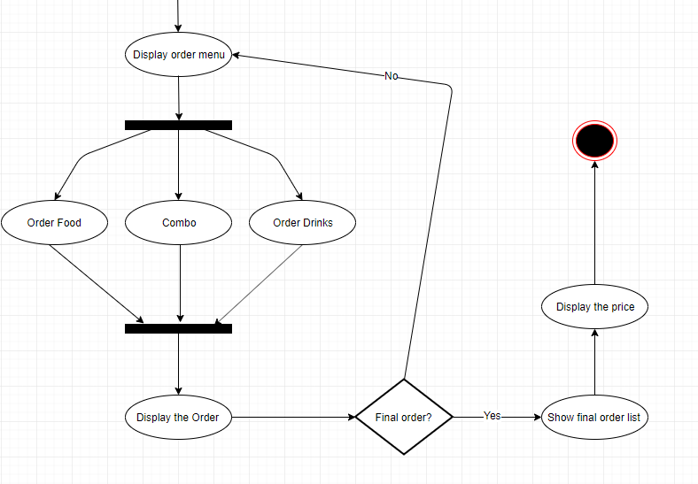

Screenshot 6.1

Screenshot 6.1 shows the order process and after the order process will confirm again with customer and show the final order list to customers.

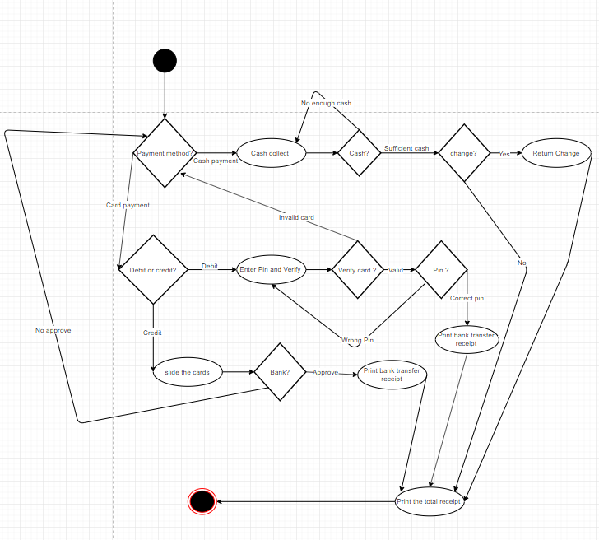

Screenshot 6.2

Screenshot 6.2 shows the payment process in activity diagram.payment method selection is given to customers. So that customer can choose to pay by cash or pay by card.if the cash is enough then will go to the step of print the total receipt.On the other hand,customer can choose to use a debit card or credit card,if the card is invalid it will straight away loop back to the payment method until the payment is successfully.So after the card is valid and transaction is make will straight away proceed to the print total receipt.

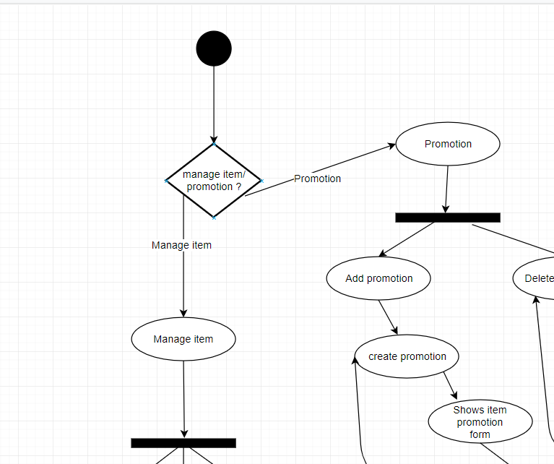

Screenshot 6.3

Screenshot 6.3 shows the item management and promotion management.when the system start will give the selection to manager whether manage item or promotion?

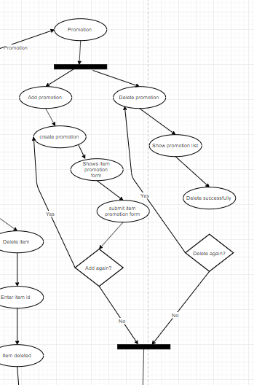

Screenshot 6.4

Screenshot 6.4 shows after choosing manage promotion,the manager can choose to add or delete promotion.if add promotion manager need to fill up the promotion form to activate the promotion.For delete promotion,manager can delete the promotion using promotion list.

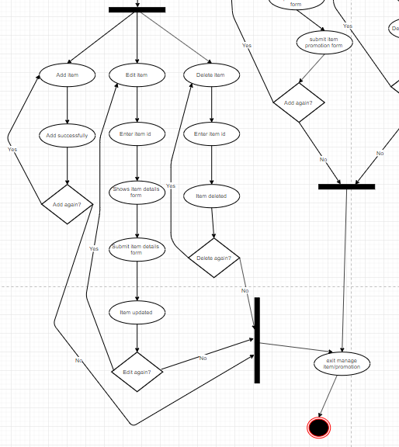

Screenshot 6.5

Screenshot 6.5 shows item management process.manager need to select the selection (add,edit,delete).For edit site,manager need to enter the item id to edit the item.On the delete site, also need to enter item id to delete the item.

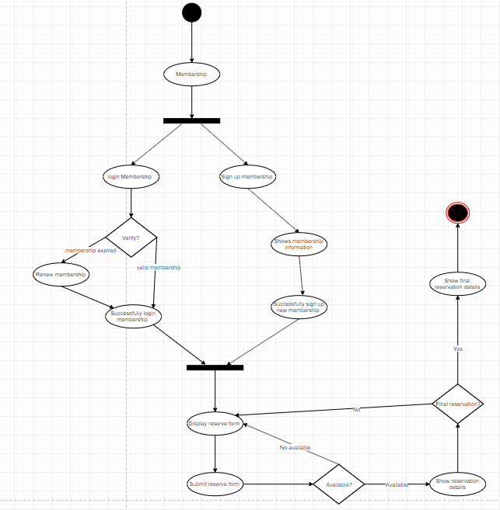

Screenshot 6.6

Screenshot 6.6 shows open/sign up membership and reservation.When customer want to reserve a table, their need to have a membership.At the start of the system will require customers to sign in their membership.if the membership is expired, their need to renew the membership. For new customers can sign up for the membership and system also will show the membership expired and information for new customers.After open/sign up membership customers can reserve a table for specific time period. If the table is not available, the system will loop back the form and require customer to re-enter the period of time again.

# 8.0 identifying key scenarios of business use cases, using primary and alternative paths

The primary paths of this activity diagram is order process. Alternative paths are the item management / promotion management, open/sign up membership and reservation. The main paths of the system is the order process.

# 9.0 Attach annotations to the sequence diagram



Screenshot 7.0

Screenshot 7.0 shows the start symbol of the system. This black circle is represent the initial action state.



Screenshot 7.1

Screenshot 7.1 shows the the action flow.An action flow arrow is to indicates the action from an object.

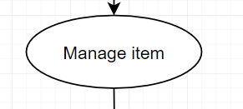

Screenshot 7.2

Screenshot 7.2 shows the the activity.this rounded rectangle shape can represent an activity or process in the activity diagram..



Screenshot 7.3

Screenshot 7.3 shows the fork node. This is used to separate a single flow into multiple concurrent flows.

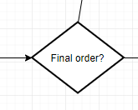

Screenshot 7.4

Screenshot 7.4 shows the decision with alternate paths. This will be use When an activity require a decision to move into another activity.

# 10.0 Reference

[1] Amanda Athuraliya.13 june 2019,Sequence Diagram Tutorial: Complete Guide with Examples<<https://creately.com/blog/diagrams/sequence-diagram-tutorial/>>.[accessed 11 November 2019]

[2] Donald Bell.15 January 2004, The sequence diagram<<https://developer.ibm.com/articles/the-sequence-diagram/>>.[accessed 12 November 2019]

[3] Unified Modelling Language (UML) | Activity Diagrams. Available<<https://www.geeksforgeeks.org/unified-modeling-language-uml-activity-diagrams/>>[accessed 10 November 2019]

[4] Activity Diagram. Available<<https://www.smartdraw.com/activity-diagram/>>[accessed 11 November 2019]

[5]DHX.25 June 2018,UML Activity Diagram for Business and Programming.Available<<https://dhtmlx.com/blog/uml-activity-diagram-business-programming/>>[accessed 11 November]